Recommendation System Based on Customer Reviews

In this project we are recommending products to user by analysing past user’s AMAZON reviews data with the help of NLTK deep learning model. First we clean reviews and then extract ratings and reviews from dataset and then feed to NLTK deep learning algorithm to train a model. After training model application will accept product or brand name from user and then recommend new product to user based on reviews and ratings. This application will display rating and reviews also which describe why this recommended product is best.

To implement this project we have designed following modules

1. Register: using this module users can signup with application
2. Login: after signup user can login to application
3. Test Data for Recommendation: using this module user can enter any test data and if related data and its reviews available then application recommend best review product.

To run project first create database in MYSQL by copying content from ‘DB.txt’ file and then paste in MYSQL

Now double click on ‘runServer.bat’ file to start DJANGO webserver like below screen

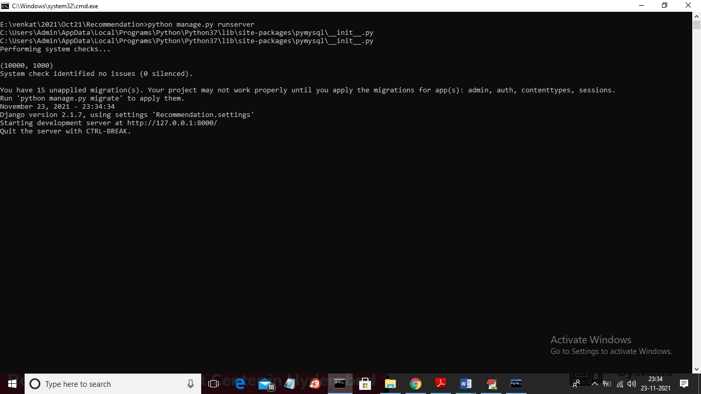

In above screen server started and now open browser and enter URL as ‘http://127.0.0.1:8000/index.html’ and press enter key to get below screen

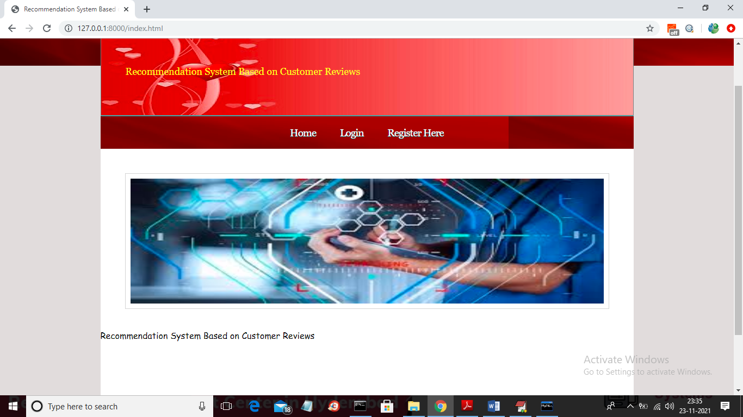

In above screen click on ‘Register Here’ link to get below signup page

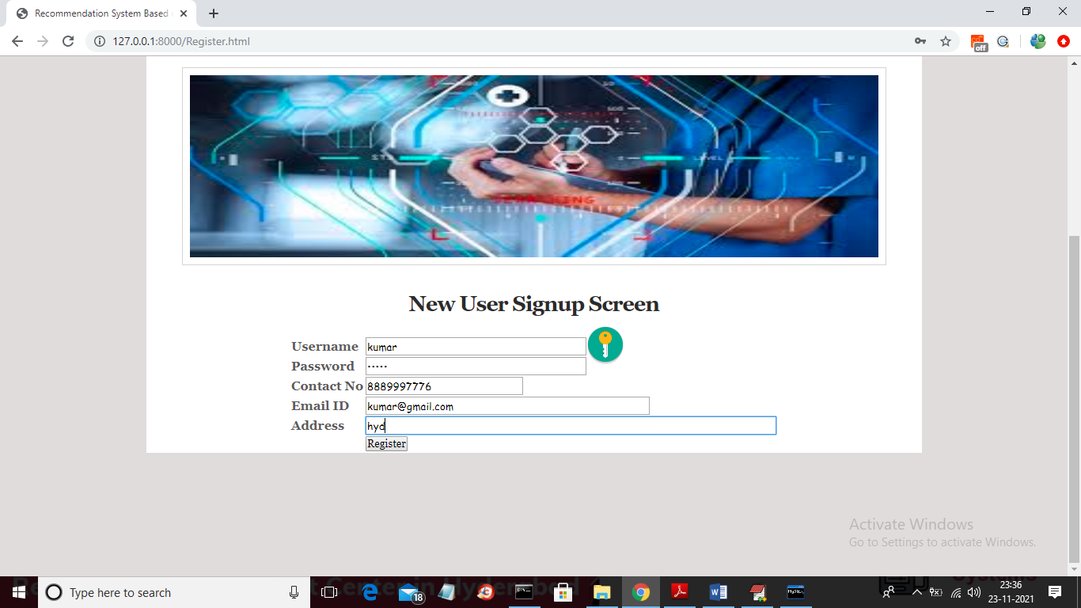

In above screen user entering signup details and then click on ‘Register’ button to get below screen

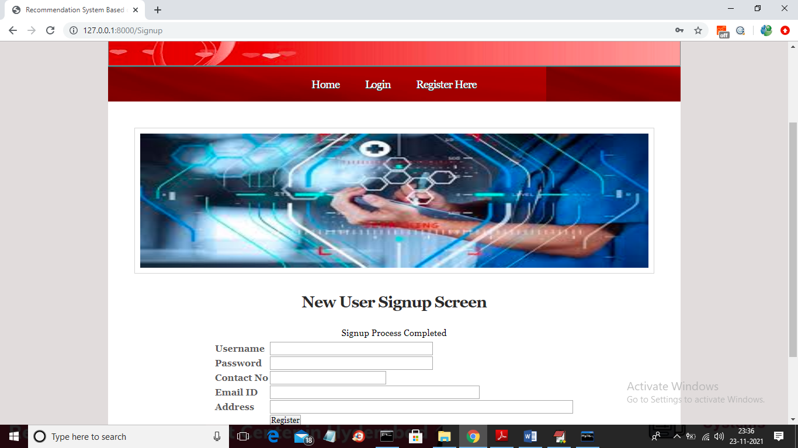

In above screen signup process completed and now click on ‘Login’ link to get below screen

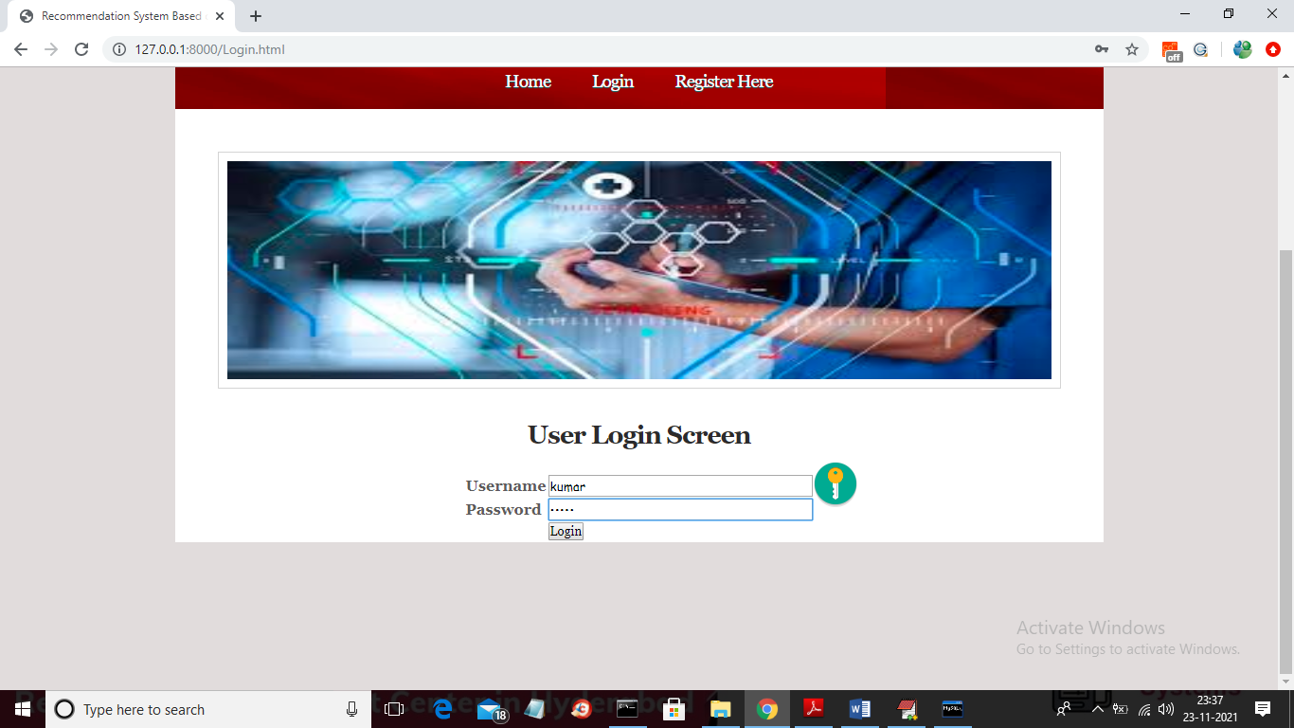

In above screen user is login and after login will get below screen

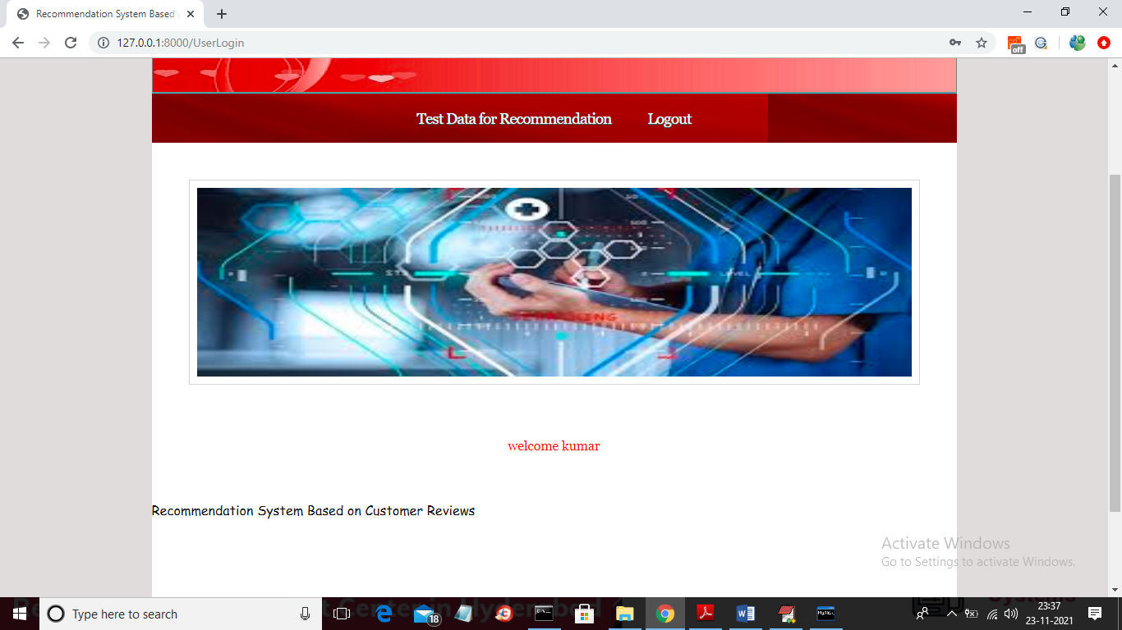

In above screen click on ‘Test Data for Recommendation’ link to get below screen

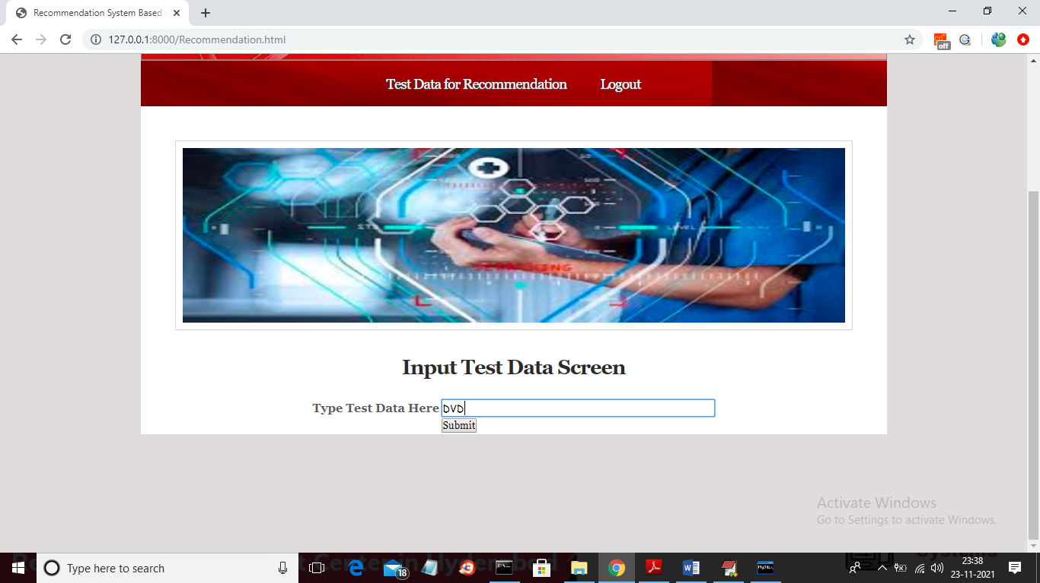

In above screen I entered product name as ‘DVD’ and press button to get below output

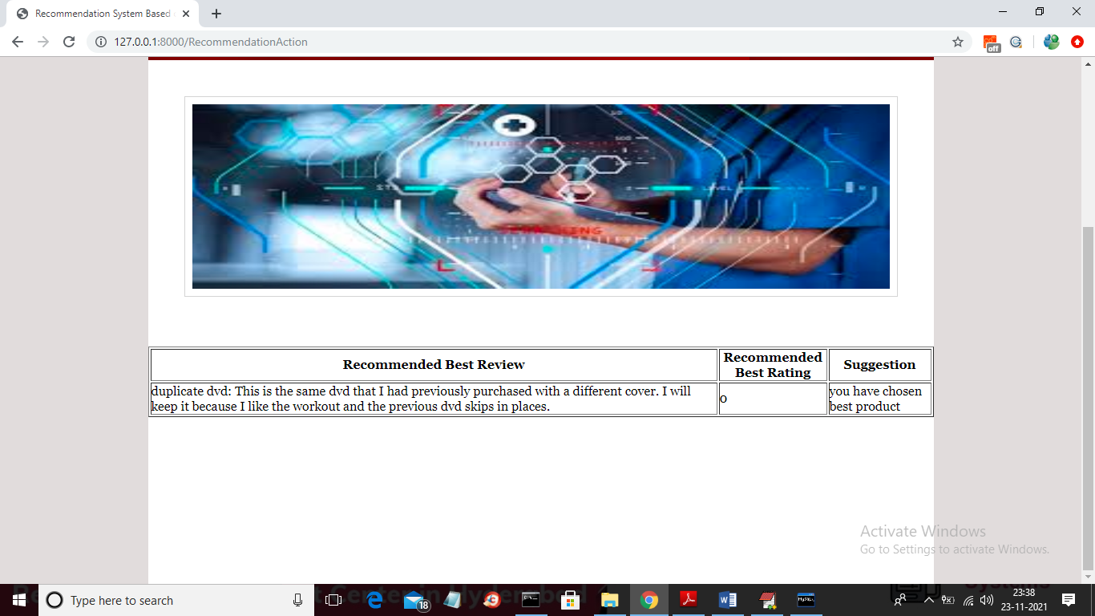

In above screen we are getting recommended review and rating for given product and in above 0 means rating is low and 1 means rating is high and now try another product

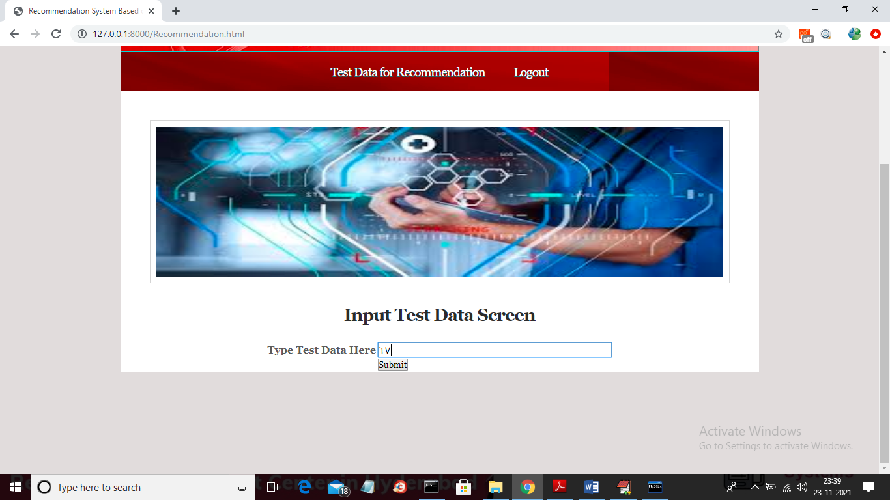

In above screen I entered product as TV and press button to get recommended review

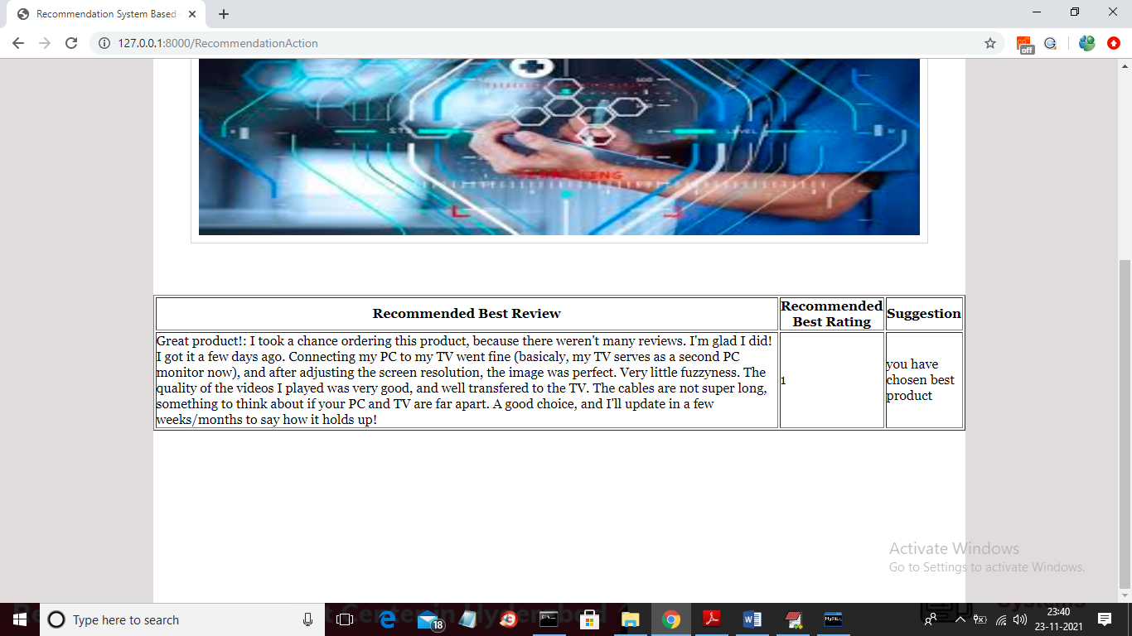

In above screen we got rating as 1 which means product is recommended and similarly you can give any test data from dataset to get recommended reviews and ratings

